To book a Covid-19 vaccine booster or both a Covid-19 vaccine booster and Flu vaccine appointment please book using the national booking service and input our postcode AL5 4SE to book an appointment at Topkins Pharmacy .

The booking page can be accessed using the following link

https://www.nhs.uk/nhs-services/covid-19-services/covid-19-vaccination-services/book-covid-19-vaccination/

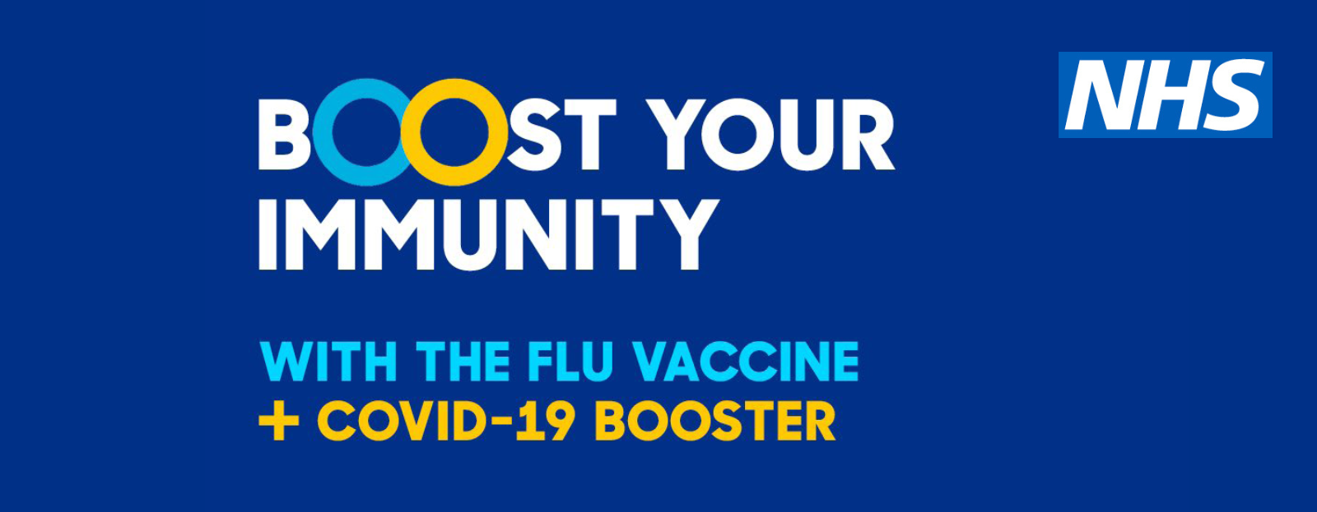
We offer NHS Flu vaccines and private Flu vaccines for those who are not eligible for free NHS flu vaccines. To book only a Flu vaccine please book using the booking system on our website which can be accessed via topkinspharmacy.setmore.com

